AI-Driven Exploration and Prediction of Company Registration Trends with Registrar of Companies (RoC)

**Introduction:**

AI-driven exploration and prediction involve using artificial intelligence (AI) techniques and data analysis to explore datasets, uncover patterns, and make predictions or forecasts. This approach can be applied to various domains,

including finance, healthcare, marketing, and more. Here's an overview of the key steps and concepts involved in AI-driven exploration and prediction.

# Problems and solutions in Exploring and predicting company registration:

Exploring and predicting company registration trends using AI-driven methods with data from the Registrar of Companies (RoC) can indeed present several challenges and problems. Here are some common issues you may encounter :

# Data Quality and Availability:

**Problem :** RoC data may contain errors, missing values, or

inconsistencies. It might also be limited in scope or not updated in real-time.

**Solution :** Data preprocessing and cleansing are crucial. You may need

to fill gaps, correct errors, and augment the dataset with additional sources

where possible.

# Dat

**aPrivacyandSecurity:**

data often contains sensitive information about

**Problem :** RoC

companiesandindividuals.Handlingthisdatamustcomplywithprivacy

regulations

.

**Solution:**Implementstrictdatasecuritymeasures,anonymizedata

whennecessary,andensurecompliancewithrelevantdataprotectionlaws, suchasGDPRorHIPAA .

**ModelComplexity:**

**Problem :** Building accurate AI models for predicting trends may require complex algorithms and substantial computational power.

**Solution :** Optimize model architectures, use feature selection techniques, and consider model compression to make them more manageable without sacrificing accuracy..

**Overfitting:**

**Problem:** AI models can overfit the training data, resulting in poor generalization to new data.

**Solution:** Implement regularization techniques, cross-validation, and careful hyperparameter tuning to prevent overfitting.

**Interpretability:**

Problem: AI models can be challenging to interpret, making it difficult to explain the reasoning behind predictions.

**Solution :** Use interpretable models when possible, employ visualization techniques to explain results, and consider model explain ability tools.

**Problem:**AImodels

**BiasandFairness:**

**Problem :** The data from RoC may be biased, leading to biased predictions and potentially unfair outcomes.

**Solution :** Perform bias analysis on your data, and implement fairness- aware algorithms and post-processing techniques to mitigate bias.

# Lack of Historical Context:

**Problem :** Trends may be factors influenced by historical events or external not present in the data.

**Solution :** Incorporate external data sources, such as economic indicators, news data, or regulatory changes, to capture historical context.

# Regulatory and Compliance Changes:

**Problem :** Regulatory changes can significantly impact company registration trends, and these changes may not be reflected in historical data.

**Solution :** Stay informed about regulatory changes, and consider integrating real-time data sources or monitoring regulatory updates.

**ModelValidation:**

**Problem :** Accurately validating AI models for trend prediction can be challenging, as there might not be a ground truth to compare against.

**Solution:** Use appropriate evaluation metrics, conduct back-testing where possible, and involve domain experts in validation.

**Long-termTrendPredictions:**

**Problem:** Predicting long-term trends accurately is difficult due to the dynamic nature of markets and economies.

**Solution:** Consider using rolling forecasts and regularly update your models with new data to adapt to changing conditions**.**

**ResourceConstraints:**

**Problem:** Building and maintaining AI models can be resource-intensive in terms of time, budget, and expertise.

**Solution:** Allocate sufficient resources, including skilled data scientists, computing infrastructure, and funding, to tackle the project effectively.

**Step:1-Data cleaning and preprocessing:**

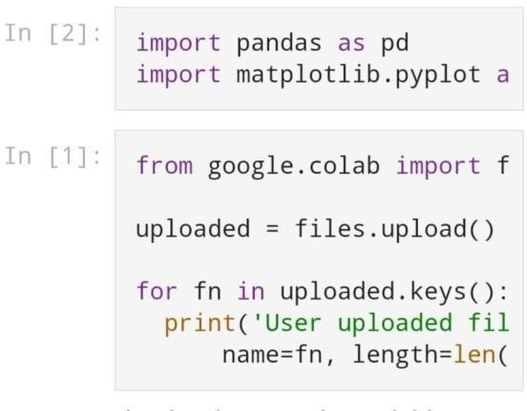

# Step:2-Data set :

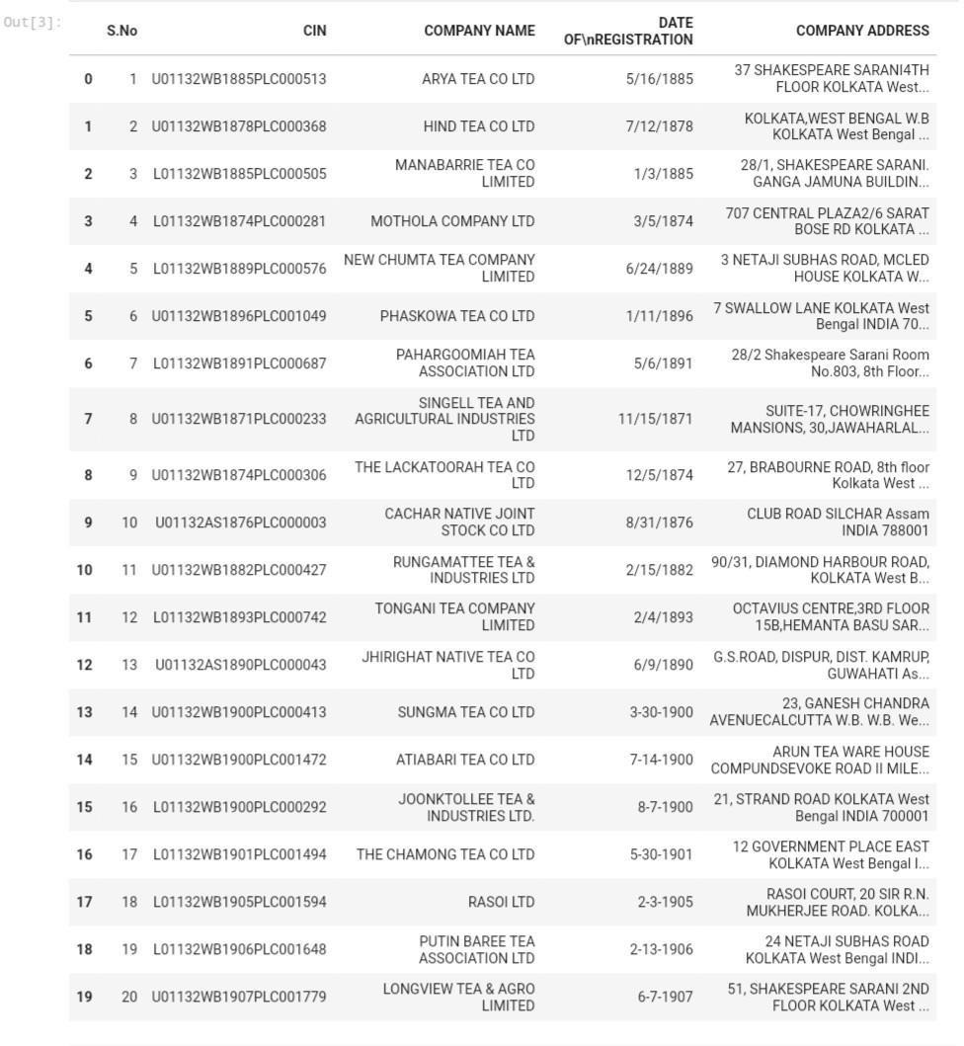

**Step:3-Plotting of data :**

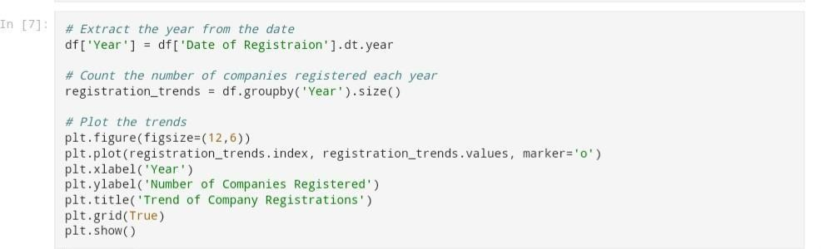

# Step:4-Data visualization:

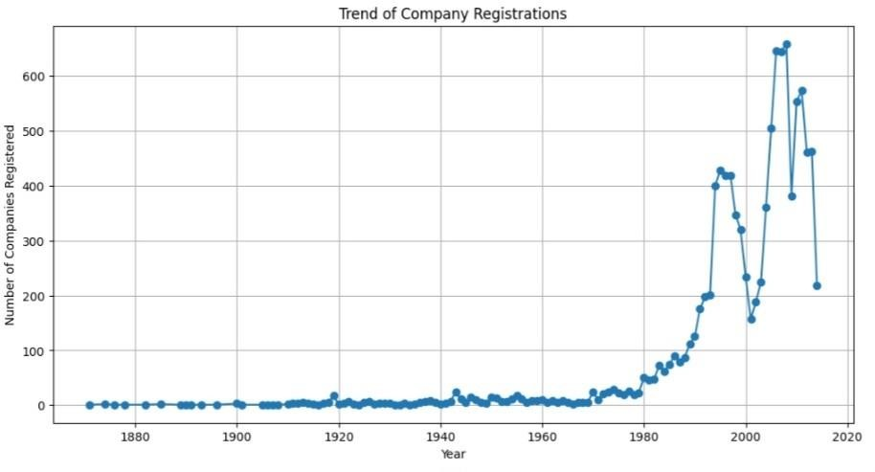

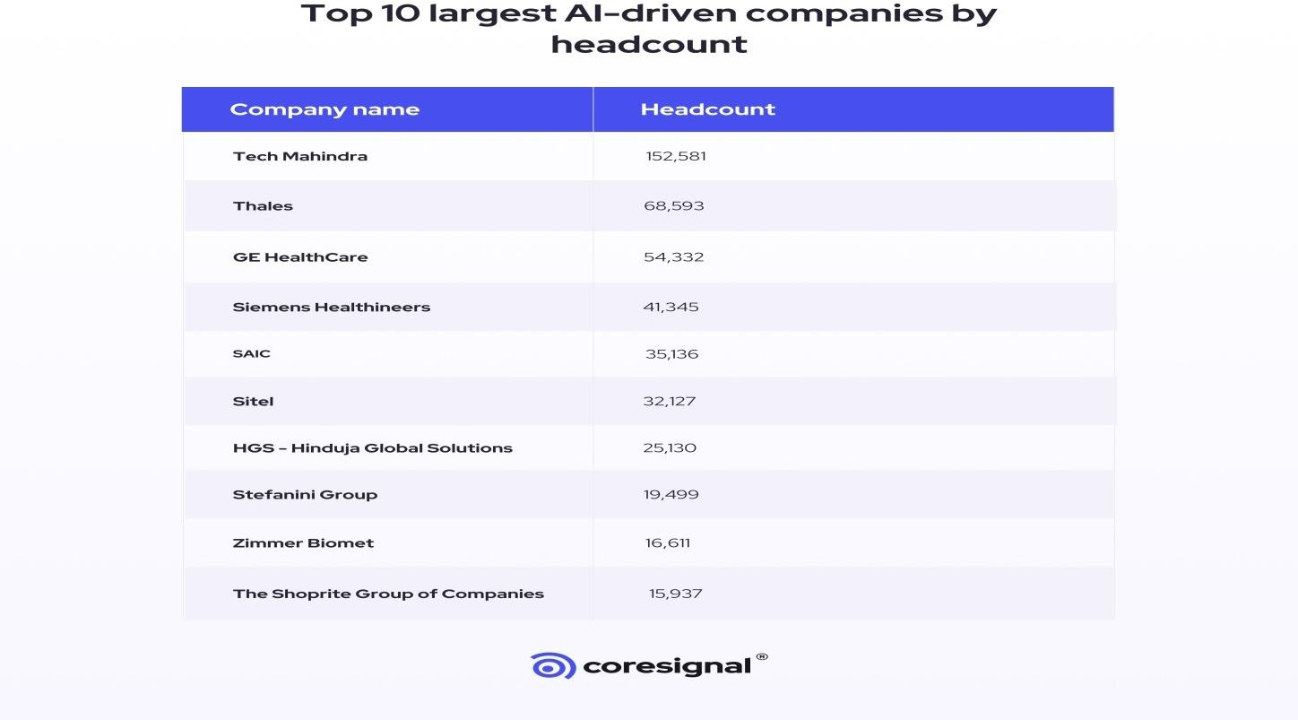

**New AI-driven companies: Top 5 countries**

Data shows that the U.S. has the highest number of AI-driven companies that were founded between 2020 and 2023.

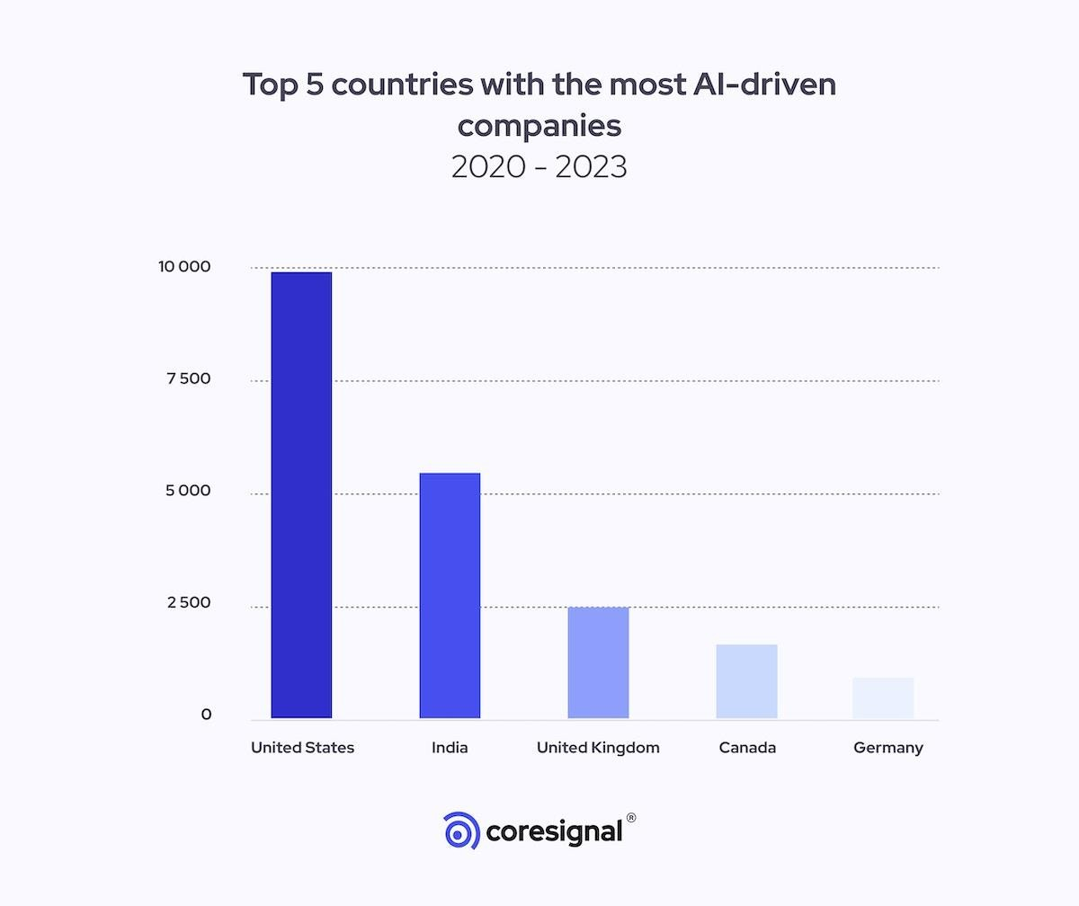

**The growth of AGI-related (Artificial General Intelligence) companies**